Resume

Cover letter
&
Cold Email

Templates

Join our telegram channel for more updates ( Lets Code )

ATS Friendly Resume template

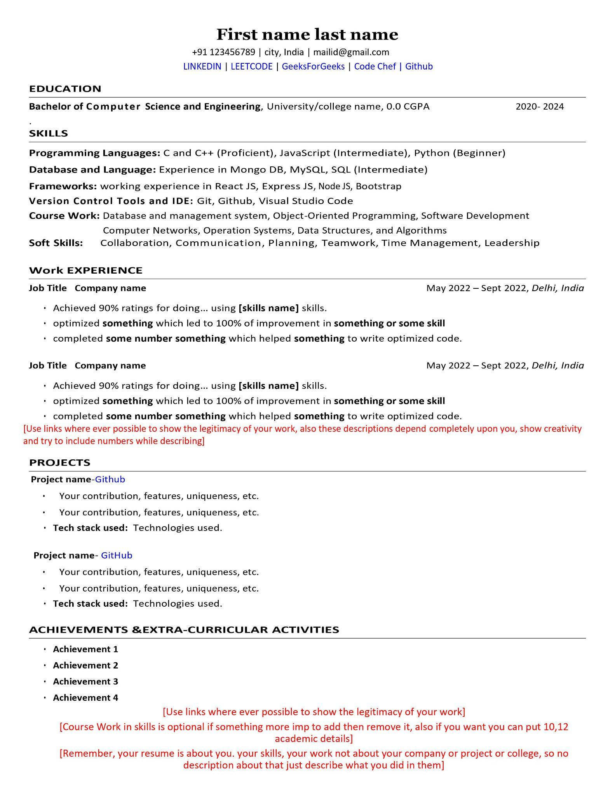
Download this template from here - Resume Template

Cover Letter Template

[Your Name]
[Your Address]
[City, State, ZIP Code]
[Your Email Address]
[Your Phone Number]
[Today's Date]

[Employer's Name]
[Company Name]
[Company Address]
[City, State, ZIP Code]

Dear [Employer's Name],

I am writing to express my interest in the [Job Title] position at [Company Name], as advertised on [where you found the job posting]. With a [mention relevant years of experience] background in [industry/field], I am confident in my ability to contribute to your team and bring valuable skills to the role.

Throughout my career, I have [mention key achievements or experiences relevant to the job]. My expertise in [specific skills relevant to the job] has allowed me to [mention how you've made a positive impact in previous roles]. I am particularly drawn to [Company Name] because of [specific reasons you admire about the company, such as its values, projects, or industry reputation].

I am impressed by [Company Name]'s commitment to [mention something specific about the company, such as innovation, sustainability, etc.]. I believe my skills and experiences align well with the requirements of the [Job Title] position, and I am eager to contribute to the success of your team.

Enclosed is my resume that further outlines my qualifications. I welcome the opportunity to discuss how my skills and experiences make me a perfect fit for your team. I am available for an interview at your earliest convenience and can be reached at [Your Phone Number] or [Your Email Address].

Thank you for considering my application. I look forward to the possibility of contributing to the continued success of [Company Name].

Sincerely,

[Your Name]

Cold email templates

Template for Job Inquiry:

Subject: Inquiry Regarding [Job Title] Opportunity

Dear [Hiring Manager's Name],

I hope this email finds you well. My name is [Your Name], and I am writing to express my interest in the [Job Title] position listed on [where you found the job posting].

With a background in [your relevant skills or experiences], I am confident in my ability to contribute to your team's success. I am particularly drawn to [specific aspects of the job or company], and I am eager to bring my skills in [mention a relevant skill] to support [Company Name]'s goals.

I have attached my resume for your reference. I would greatly appreciate the opportunity to discuss how my experience aligns with the needs of your team. Please let me know if there is a convenient time for a brief call or meeting.

Thank you for considering my application. I look forward to the possibility of discussing how my skills can benefit [Company Name].

Best regards,

[Your Full Name]
[Your Resume Attached]
[Your Contact Information]

Template for follow-up-email

Subject: Follow-Up on [Your Previous Subject Line]

Hi [Recipient's Name],

I hope this message finds you well. I wanted to follow up on the email I sent last [mention the specific day or date] regarding [briefly remind them of the purpose of your initial email].

I understand you're likely busy, and I appreciate your time. I remain very interested in [highlight the main point or benefit you mentioned in the initial email] and would love to hear your thoughts or answer any questions you might have.

If now is not the best time, please let me know when it would be convenient for a brief call or meeting. I'm flexible and would like to accommodate your schedule.

Thank you again for considering my [collaboration/job inquiry/networking] proposal. I'm looking forward to the possibility of connecting and discussing this further.

Best regards,

[Your Full Name]
[Your Contact Information]

Template to ask referral from employees

Subject: Quick Question About [Company]

Hi [Employee's Name],

I hope this email finds you well. I came across your profile on [LinkedIn/Company Directory] and noticed your connection to [Company]. I'm currently exploring opportunities in [specific industry/field], and after learning more about [Company], I'm particularly impressed with [mention something specific about the company, such as its values, projects, or culture].

I noticed you have experience at [Company], and I'd love to hear more about your journey and insights into the company. If you have a few minutes, could we schedule a brief call or grab a virtual coffee? I'm interested in understanding more about the company culture and any advice you might have for someone looking to join [Company].

Additionally, if you feel comfortable, I would appreciate any guidance on the application process or potential referrals within the company.

Thank you so much for considering my request. I understand you're busy, and I truly appreciate your time and insights.

Looking forward to the possibility of connecting!

Best regards,

[Your Full Name]
[Your LinkedIn Profile/Contact Information]

Use the below List to send cold emails to HR and hiring managers, also send cold emails to companies' official email IDs.

Leading Startup Companies in Bangalore-
https://drive.google.com/file/d/1vOFKE1MpbrmAvzoDHwr7Pd5KLAYfVcTM/view

900+ Startups Hiring REMOTE list-
https://drive.google.com/file/d/1nxlDv2x0NuIwf40NstdCV3qTIsDd5SvY/view

500 + 𝐑𝐞𝐦𝐨𝐭𝐞 𝐇𝐢𝐫𝐢𝐧𝐠 Companies List - https://drive.google.com/file/d/1MfOWMA40DrxL3vSFnUgNqlXM5l8ZCejo/view

